PAYROLL
Task | Remarks
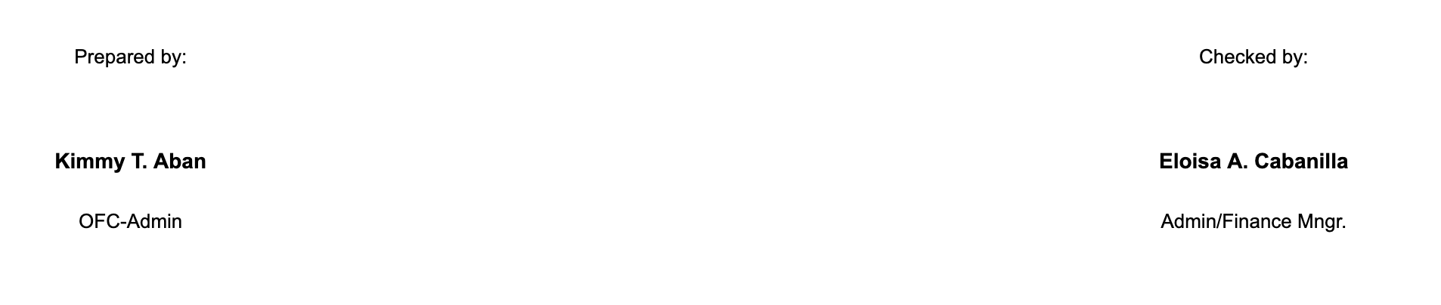
Signatories should be dynamic, depende sa company

Printable Payroll
Printable Pay slip (individual employee)
15 / 30 employees, dili sila part sa per project payroll. Per Company Payroll sila but the computation still per hour.
Make this logo dynamic


Link the counts to their respective pages


Allow the company to Edit their information. Add an icon and align it with other menus.



Add an Action button for Reports
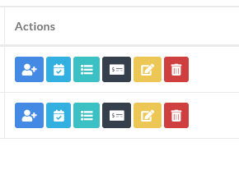
- Clicking the Reports button will redirect to the page showing the payroll summary of that particular project.
CRUD for Manage Users

